

**JSC “Kazakh British Technical University”**

**School of Mathematic and Cybernetics**

    Analysis of Data Bases

**Laboratory Work #5**

**Variant #2**

**Prepared by: Maratuly Temirbolat**

**Almaty 2021**

**Exercise 1   
Normalize to the third form the table below and build the resulted tables in SQL program**

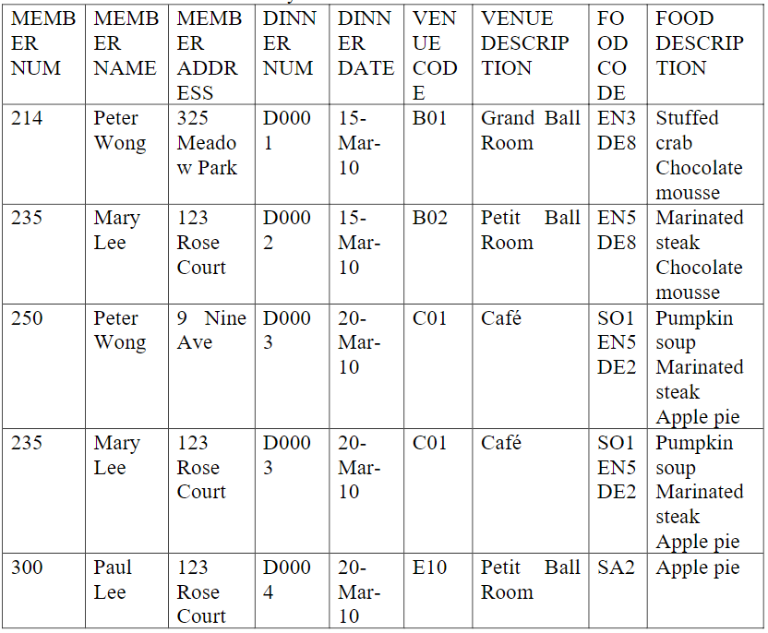

**Solution**:

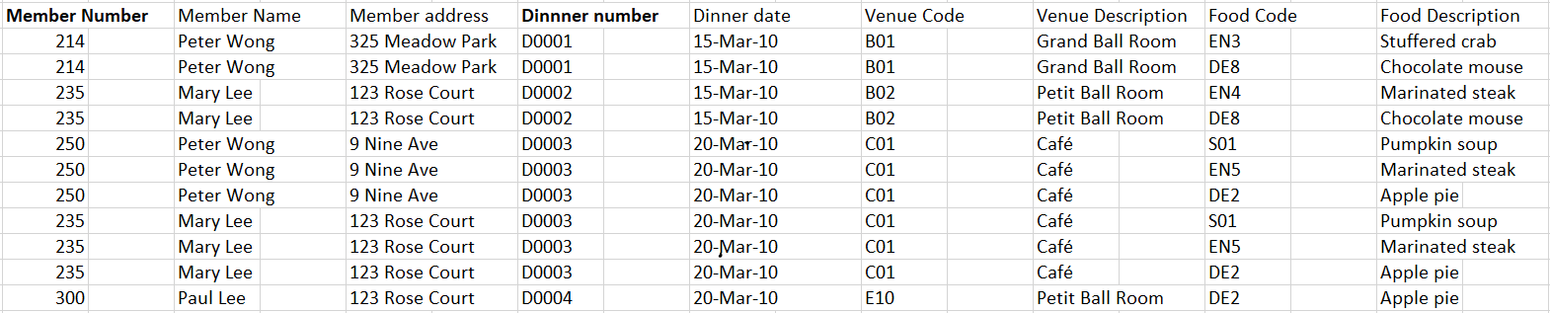The **First form** of the normalization is below. The procedure is just to repeat the information where the number of data in a cell appears more than one time. The columns in BOLD make a compound key.

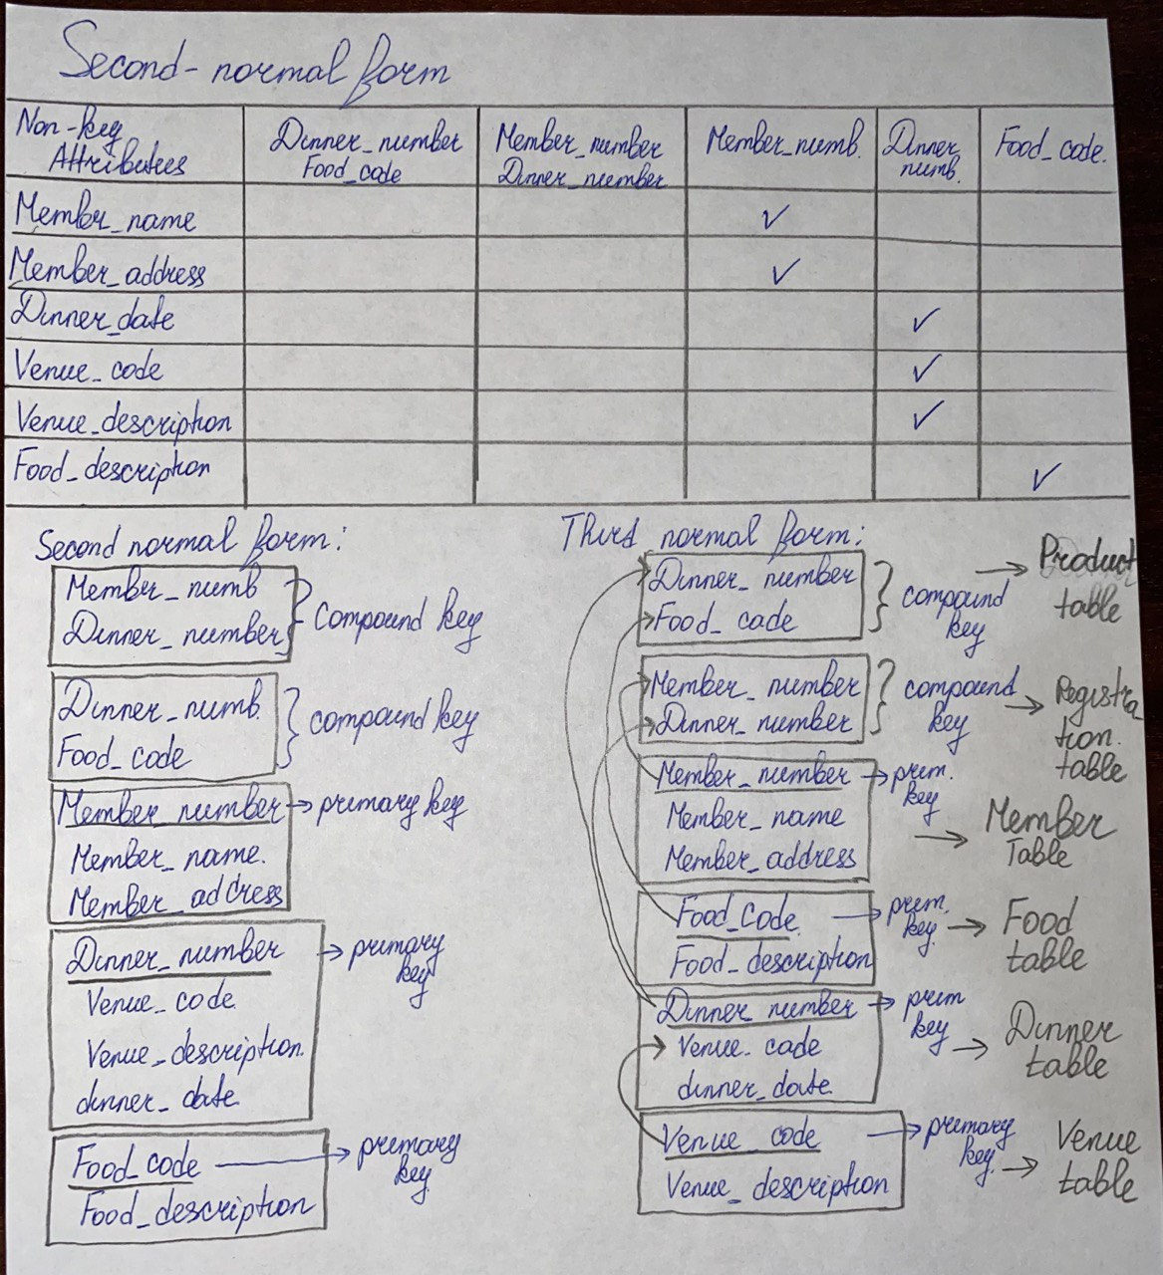The **Second Form** and **Third Form** of the normalization are the following. The steps to get the second form are: 1) Take all non-key attributes and all possible keys 2) Put a sign in which intersection each attribute is dependent on this key. It is called **Partial dependency.** For the Third form we just examine each table in order to find non-direct dependency from non-key attribute to key column and just extract it into new table catch **Transitive dependency.**

**SQL part:**

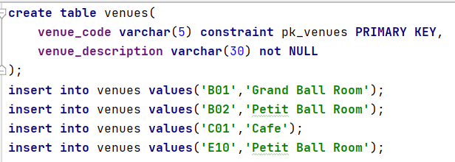

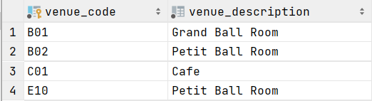

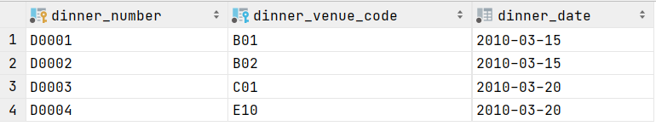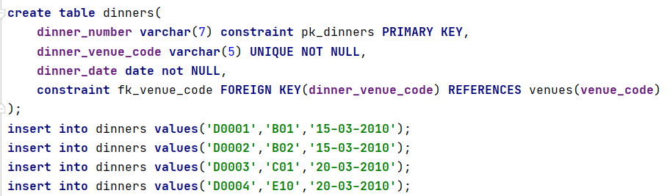

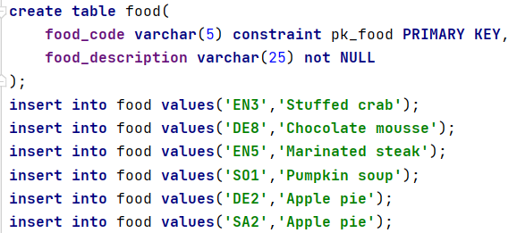

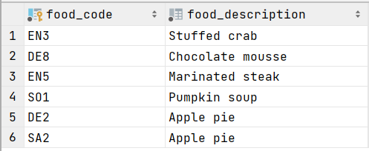

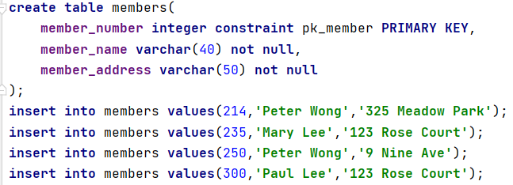

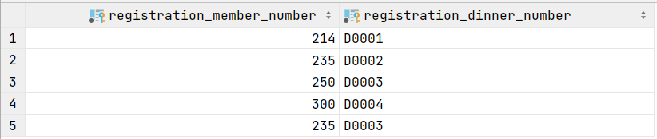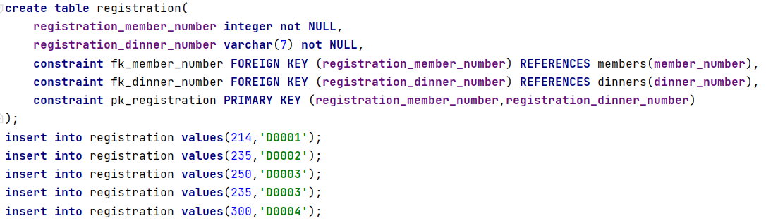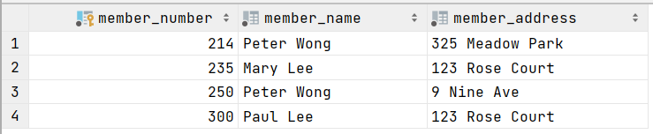

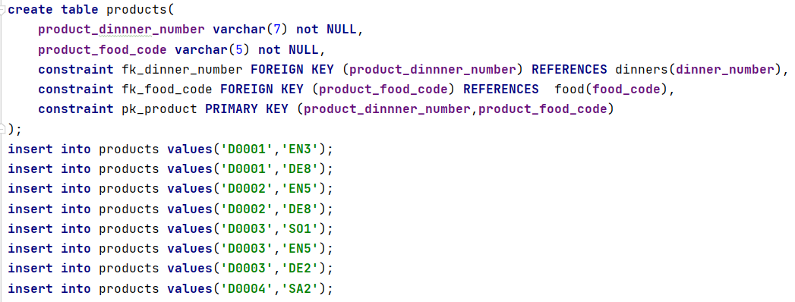

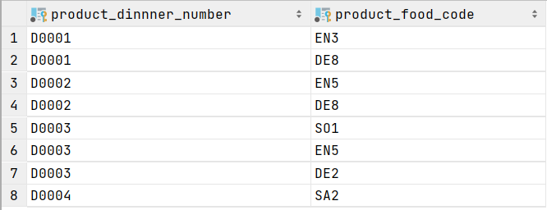

**Tasks:**

1. 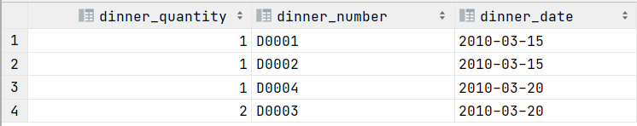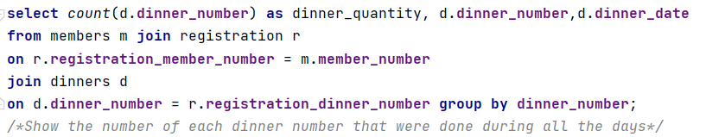Show the number of each dinner number that were done during all the days.
2. Make the request of the first 3 letters of the name where the length of the address is higher than 10

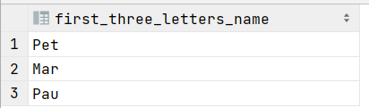

1. 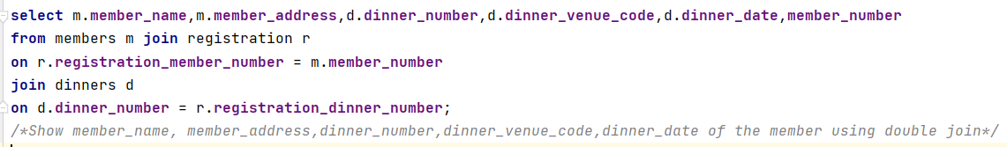Show member name, member address, dinner number, dinner venue code, dinner date, member number of the member using double join

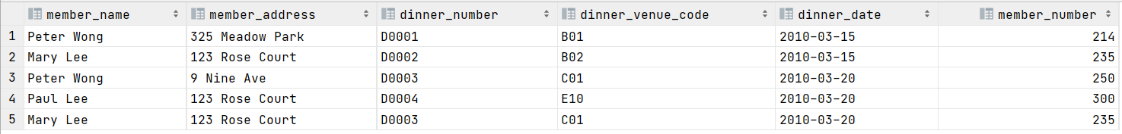

1. 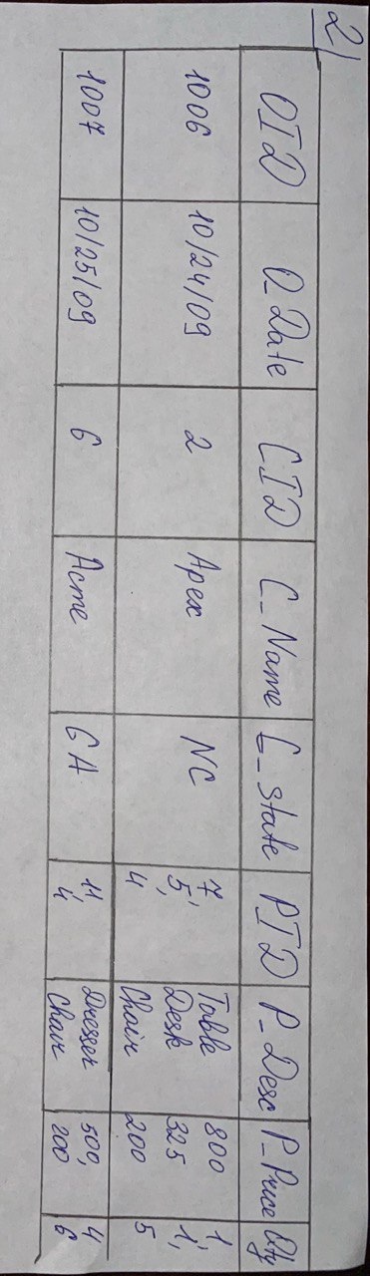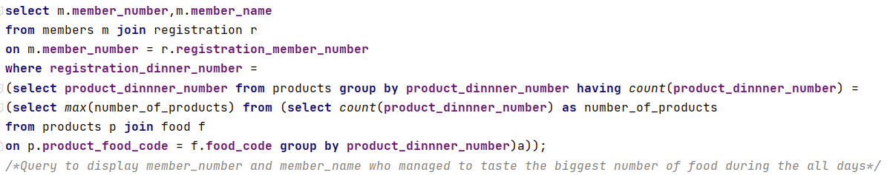Write the query to display member number and member name who managed to taste the biggest number of food during the all days

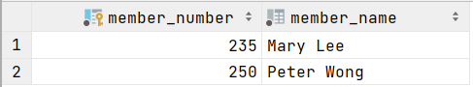

**Exercise 2**

**Normalize to the third form the table below and build the resulted tables in SQL program**

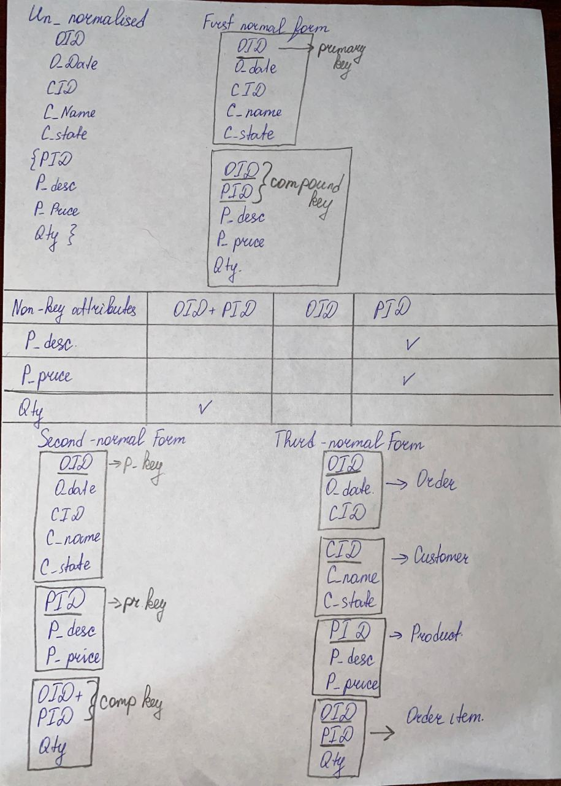

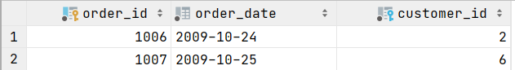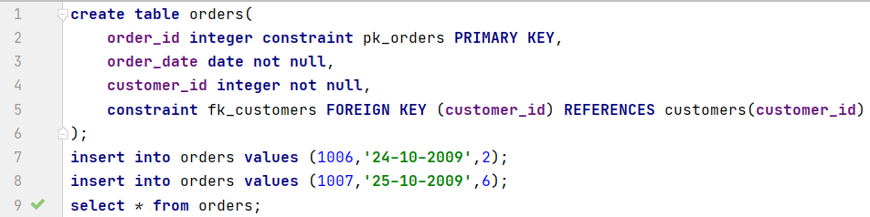**SQL part:**

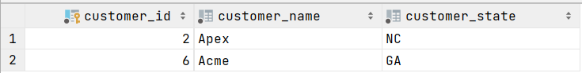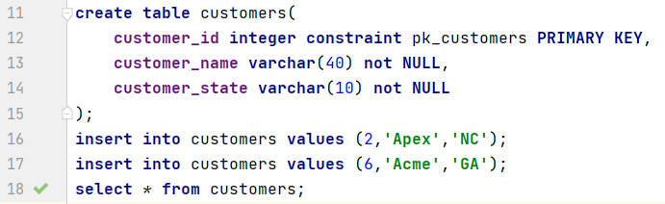

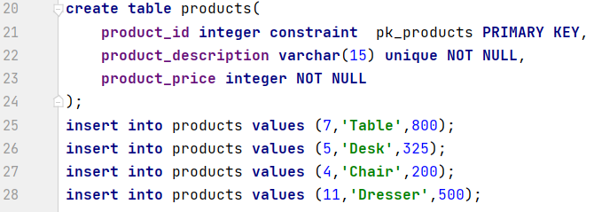

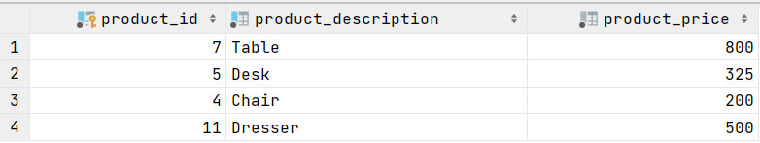

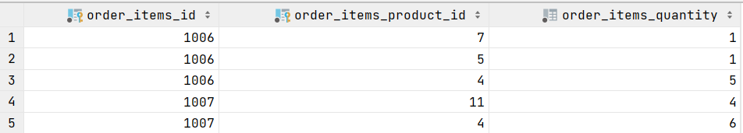

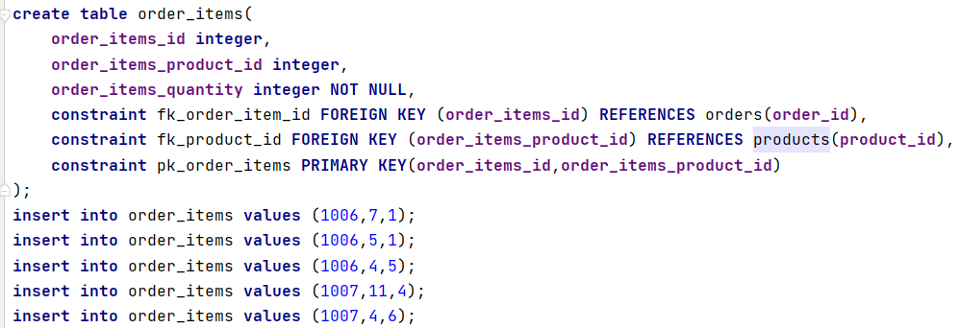

**Exercises:**

1. Show the minimum date of the order (the oldest one) that was done

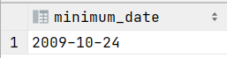

1. Show all the descriptions of the products in UPPER Case

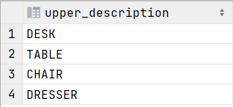

1. Show order date, customer name, customer state where order date is less than 25-10-2009 using joins

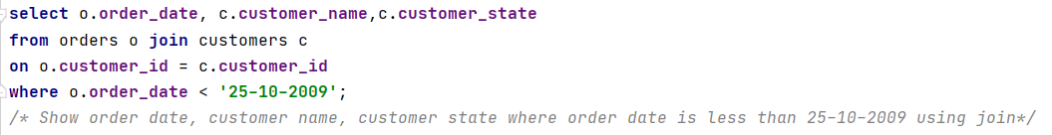



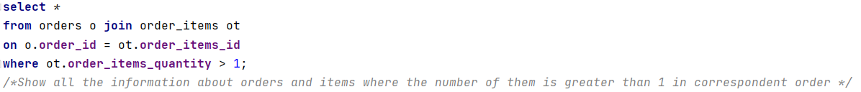 **4)** Show all the information about orders and items where the number of them is greater than 1 in correspondent order

 **5)** Show all the information of the order where the customer name starts with A and ends with x

